**Cloud, Services, Servers.**

The Cloud, a word that has taken over our I.T world in the last decade, but what is it?

Fundamentally, cloud computing is the delivery of on-demand computing services over the internet. These services include Networking, analytics, software, databases, intelligence, storage and servers. Cloud computing is elastic, scalable, fast, secure, reliable and cost-effective without sacrificing performance. Some examples of companies which use cloud computing are Netflix, Facebook, Apple, Google and Instagram.

The cloud computing has 3 main tiers of structure, Infrastructure as a service (IaaS), Platform as a service (PaaS), and Software as a service (SaaS).

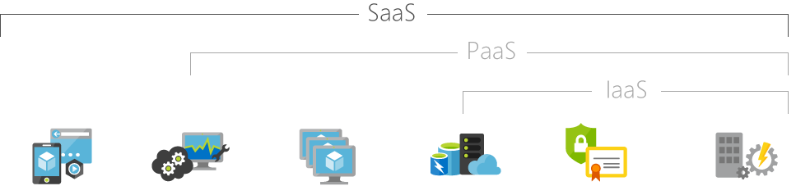

**IaaS** is a computing infrastructure supplied and managed over the internet. This is made up of servers, networks, storage and operating systems. The service is elastic which means it can be scaled up and down based on demand, the pay per usage system in place helps businesses circumvent the need of buying and managing physical servers. Examples of these service providers are AWS EC2, Rackspace and Google Compute Engine.

This service is generally used for,

* Website hosting,
* Storage and Backup,
* Testing and Development,
* Big data analysis,
* High Performance computing.

Some advantages of IaaS are,

* Eliminates capital expense,
* Improves business continuity and disaster recovery,
* Innovate rapidly,
* Act quickly when the business conditions change,
* Frees up workforce to focus on the core of the business,
* Increased stability, reliability and supportability,
* Better security.

**PaaS** is a cloud computing service which is a complete development and deployment environment, like the IaaS the PaaS includes the infrastructure supplied and managed by the provider although it now includes the development tools, data base management system and business intelligence services, examples of this service are AWS Elastic Beanstalk , Windows Azure and Apache Stratos. PaaS helps businesses circumvent the need of buying and managing software licences and the infrastructure which the software is running on.

This service uses are,

* Development Framework,
* Business Intelligence/Analytics,
* Application enhancement.

Some advantages of PaaS are,

* Use advanced development tools,
* Ease of use for overseas development teams,
* Reduces coding time,
* Manage the applications life cycle,
* Develop for multiple platforms,
* Gain the development benefits without requiring extra staff,
* Includes all advantages mentioned in IaaS

**SaaS**this is a service for delivering software applications over the internet, normally on a subscription basis. The cloud providers manage the infrastructure, software and maintenance of the SaaS, examples of this service is software like Google Apps, Slack and  DropBox. This allows consumers to rent on a pay-as-you-go basis the users will connected to the service over the internet, SaaS is used for most web-based email services.

Some advantages of SaaS are,

* Only pay for what you use,
* Client based software (no need to install the program),
* Access app Data from anywhere,
* Mobile workforce capabilities.

Currently the disadvantages that come with cloud computing are,

* Requires internet connectivity,
* Requires high bandwidth,
* Security vulnerabilities,
* Variation of costs,
* Lack of support.

**What developments will we see in the next 3 years?**

Developments in cloud computing will change computing from a physical format into a virtual one, making a strenuous task that would require a lot of staff, expensive hardware and expensive software to complete can soon be available to everyone though a subscription-based service. This will be extremely cost effective and provide a far more sustainable global I.T infrastructure. Cloud computing is becoming the centre point for innovation for a lot of the new technologies such as A.I, natural user interfaces, IoT, Quantum Computing, big data and analytics and more. These technologies and more like them will fuel this fire we know as “the cloud” and impact on most of our daily activities and requirements. For example,

* Transportation and services,
* Healthcare,
* Autonomous vehicles,
* Agriculture,
* Wearable IT,
* Digital Currency.

**What is the likely impact?**

My research has found there are predictions stating that public cloud spending in the US will reach $330B by 2022, IaaS grew 27.5% from 30.5B in 2018 to 38.9B in 2019.

Predictions continue with IaaS revenue expected to grow from 30.5b in 2018 to 76.6b in 2022 and SaaS revenue expected to grow from 80b in 2018 to 143.7b in 2022.

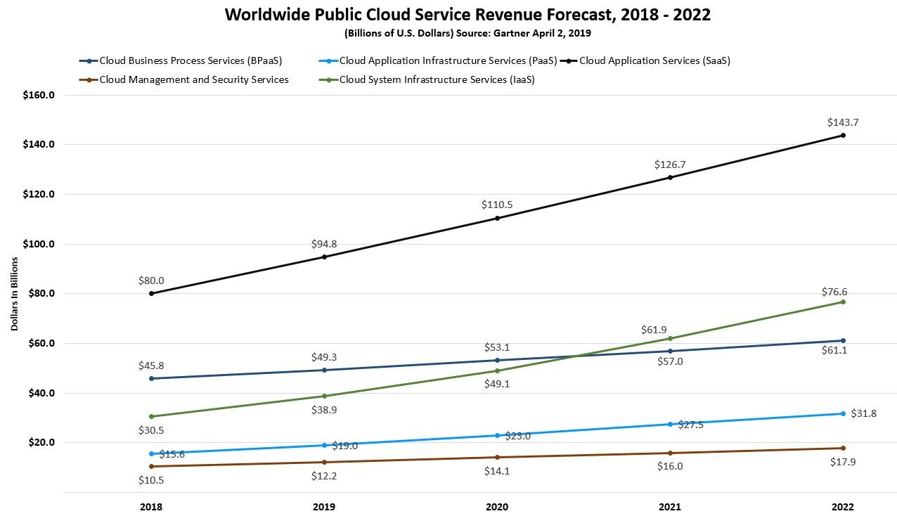

With these revenue predictions we will see more advancements in the I.T. world ranging from how businesses will manage their workflow, customer service and staff interactions.

If the end user or edge of the network will be opening their wallets for the latest and greatest new tech in this way, we will see a soar in new consumer technology – possibly wearable IoT like AR glasses which display all of your “Hey Google” queries without picking up your phone.

As business’s begin to relocate their network services to the cloud, some I.T. employees such as System Administrators, Database Administrators and Help Desk Support will become more redundant with internal businesses that employ them, although they will be able to adapt there work platform to be more suited for employment within the cloud bases companies.

I.T jobs such as Project managers, Business analysts and software developers will continue to be in high demand. Project managers are needed to reiterate concepts of cloud computing and how it impacts various projects, currently as stated by indeed.com “The average salary for a Project Manager is $127,517 per year in Australia”.

As the cloud begins to grow, we will see I.T jobs grow demand, as the cloud services grow as does the requirements for people to create, manage and maintain them. This will require I.T industry employees so adapt into the new platform and shift their skill set accordingly.

**How will this affect us?**

Day to day life for everyday people will include increasing interaction with cloud services, with a high percentage of people being completely unaware of it. As I.T innovation continues tech like driver less cars and AI will become more adopted by society and the cloud will be a huge part of its development.

As an I.T. students, we will be witness to this change over the next 3 years and be able to adapt easier to the changes and updates to day to day life that Cloud based services bring while having the ability to study and understand the processes involved. As a new tech enthusiasts, I am looking forward to the upgrade within our cloud infrastructure and excited for the possibilities it will open up for further advancements in IoT and day to day life upgrades.

As cloud platforms continue to develop, we will see gaming consoles and gaming PCs become less of a requirement for high resolution, high frame rate gaming. There are gaming platforms now like the Google Stadia and Nvidia’s GeForce Now which are using more of the clouds infrastructure potential (although I think this was an epic fail for us in Australia) to have low latency high resolution gaming streamed to handheld devices, TVs and Android TV media devices without the need to have an expensive console or high end gaming PC.

In the coming years the trucking and logistics industry will change considerably due to automation, AI and driver less vehicles this will have a huge impact on our current truck driver employment rates and therefore unemployment rates. The transport industry will be the first to adapt into driver less vehicles as they have the most to gain from its “non-stop” cost effective and efficient approach. Cloud based infrastructure will be the foundation in which this technology can be produced and utilised, 5G will also play a big part in this development and its improved bandwidth and speed will allow the vehicles to utilise cloud storage to it most efficient level.

Bibliography

Azure.microsoft.com. (2019). *What is cloud computing? A beginner’s guide | Microsoft Azure*. [online] Available at: https://azure.microsoft.com/en-au/overview/what-is-cloud-computing/ [Accessed 22 Dec. 2019].

Azure.microsoft.com. (2019). *What is IaaS? Infrastructure as a Service | Microsoft Azure*. [online] Available at: https://azure.microsoft.com/en-au/overview/what-is-iaas/ [Accessed 22 Dec. 2019].

Azure.microsoft.com. (2019). *What is PaaS? Platform as a Service | Microsoft Azure*. [online] Available at: https://azure.microsoft.com/en-au/overview/what-is-paas/ [Accessed 22 Dec. 2019].

Azure.microsoft.com. (2019). *What is SaaS? Software as a Service | Microsoft Azure*. [online] Available at: https://azure.microsoft.com/en-au/overview/what-is-saas/ [Accessed 22 Dec. 2019].

Ieeexplore.ieee.org. (2019). *IEEE Xplore Full-Text PDF:*. [online] Available at: https://ieeexplore.ieee.org/stamp/stamp.jsp?arnumber=7063168 [Accessed 23 Dec. 2019].

2022, A. (2019). *Australia public cloud services spending to hit $10B by 2022*. [online] ARN. Available at: https://www.arnnet.com.au/article/659610/australia-public-cloud-services-spending-hit-10b-by-2022/ [Accessed 24 Dec. 2019].

Collabera IT Jobs, Staffing & Recruitment. (2019). *How Will Cloud Computing Affect IT Jobs?*. [online] Available at: https://www.collabera.com/find-a-job/career-resources/how-will-cloud-computing-affect-it-jobs/ [Accessed 28 Dec. 2019].